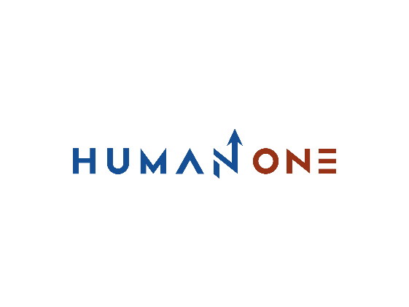

Services

Expertises

**EN**

**FR**

Get in touch

Company

Services overview

Consulting

Engineering

Technology

Operations



# Solution Operations

By leveraging industry practices and evolving domain expertise, HumanOne optimizes time-to-market and achieves greater efficiency in delivering value in production. We use best practices supported by internally developed framworks to develop your development environments and processes to ensure optimal production and organizational flexibility. We strive to keep our processes and procedures under control in order to meet deadlines in accordance with production levels. We make continuous improvement of our processes a top priority in order to guarantee sustainable maintenance of your product or solution.

Translated with www.DeepL.com/Translator (free version)

Let’s Talk

DevOps transformation

Choose the best DevOps method and implement the necessary changes

Support system optimization

Examine the existing operations and implement new processes

## **What we do**



**DevOps transformation**

* Development of the DevOps strategy
* Implementation of the DevOps transformation

**Support system optimization**

* Management of support activities
* Implementation of service desk operations

## **What you get**



Implementing an effective support mechanism

Building and deploying a cloud solution

Decrease development cycle times and provide rapid feedback with an impactful DevOps strategy



## **Solution Operations highlights**



Become agile and optimize your company's IT operations with our robust DevOps services. We help you enhance the scaling of your solution or product while keeping costs to a minimum.

Speed up delivery by implementing and setting up continuous integration (CI) and continuous delivery (CD) based on Amazon Web Services (AWS), Microsoft Azure and Google Cloud Platform technologies

By reducing development and implementation cycle times with our process frameworks, we help you reduce operational costs and boost the efficiency of IT operations



DevOps Best Practices

Continuous integration and deployment

Mature operations processes

Switch to agile mode and reinvent your core business

Get in touch

## **Why HumanOne**

**A Client-centered strategy**

We make your business goals our top priority. We are committed to turning your ideas into real solutions exactly as you have imagined and specified. We are committed to delivering a customized offer according to your business objectives and needs while working on your particular specifics.

**International standards**

Our processes are compliant with ISO 26262, ISO 27001:9001, GDPR, ASPICE and other standards, rules and regulations. We always seek to build solutions that are fully aligned with international standards and local regulations.

**Extensive micro-services expertise**

We are always looking to deliver next-generation technologies that make extensive use of microservices. Our agile frameworks stay ahead of the constantly changing market demands, allowing us to perpetually evolve and grow our solutions.

**Cloud-agnostic DevOps**

We assist you identifying and designing cloud platform agnostic solutions that best meet the client's requirement and needs.

### **Production support experience**

We have sophisticated support systems backed by many years of industry experience in supporting large enterprise clients.

**Security practices**

At HumanOne your data privacy is our number one priority. We take care of it at the informational, procedural and physical levels. We identify and resolve any possible threats through continuous surveillance of your systems and processes, thus protecting your data from potential compromises.

